Movie Database Management System

Output
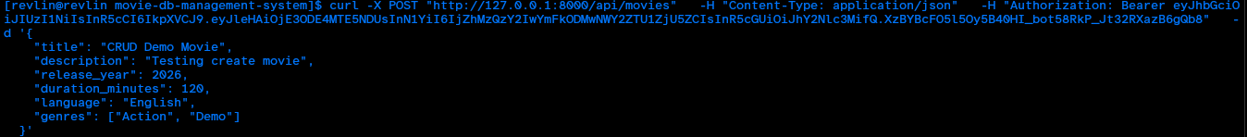
test movie creation. Just does a post command where we create a movie entry and store it in mongodb.

Fetching the entry from the db

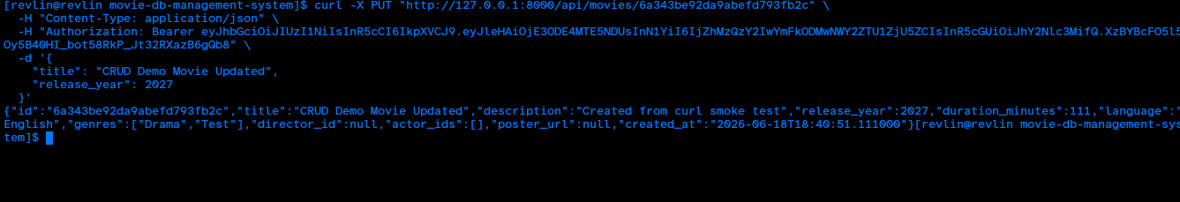
Updating the movie details

deleting the record from the db

swagger docs

